Troubleshooting Muirhead Protocol

\*If you notice that Muirhead temperature has been fluctuating and rising by a couple degrees there may be an air bubble in the connecting tube

Required materials:

Meter stick

Hanger (for opening floor hatch inside Muirhead)

Compressed gas duster

Procedure

1. Take a meter stick and measure liquid nitrogen levels and see if it matches the level reader on the controller. If there are discrepancies, continue to step 2
2. Locate the clear tube connected to the controller system. Then disconnect the tube (may have to yank pretty hard).

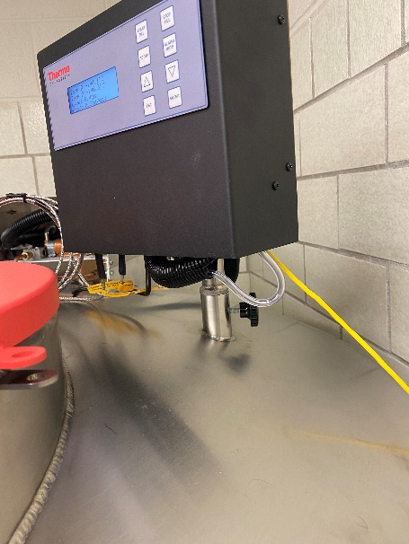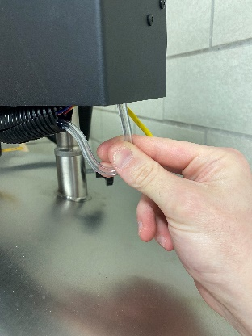

Controller

Clear tube

1. Remove red lid from Muirhead
2. Once the clear tube in disconnected and lid is off tank, pump the compressed air through the tube
3. Continue to dispense the air until you see vapor coming out of Muirhead

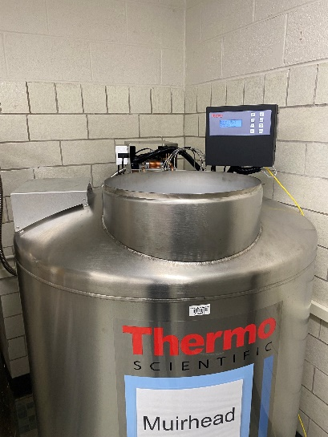

1. Once you see the vapor coming out of Muirhead, continue for 30 seconds. This should clear the air tube and allow for accurate volume level calibration.
2. Reconnect the clear tube to the controller system and close the tank.
3. Monitor the temperature to see if this fixes the issue. If issue is not fixed, call service support
   1. Number: 1-800-4384851
   2. Email: [ServiceSupport.led.asheville@thermofisher.com](mailto:ServiceSupport.led.asheville@thermofisher.com)
      1. When placing a service request it is useful to know the tank’s serial number: CAB2122220036